SOFTWARE SIMULATION OUTPUTS REPORT
Software Simulation Outputs Report
Project: Darvycom Brisbane Engineering Laboratory Network and DSP Upgrade
Unit: ICTTEN827
Project Manager: Leonardo Matias Ciarcia
Document ID: C6-SIM-OUTPUT-01
Version: 1.0
Date: 12 March 2026

1. Executive summary
This report documents the software tools, simulation procedures, calculated outputs and evidence requirements used to evaluate the Darvycom engineering solution.
The main software environments are:
- Cisco Packet Tracer for network configuration and connectivity;
- MATLAB for DSP, convolution and queue calculations;
- PRTG Network Monitor for representative traffic monitoring;
- virtual spectrum analyser and oscilloscope tools for signal evidence.
Packet Tracer connectivity was completed successfully after correcting VLAN, trunk, default gateway and interface settings. MATLAB outputs in this report are calculated expected outputs and should be supported by screenshots produced when the supplied code is executed.

2. Simulation objectives
The simulations were designed to verify:
- VLAN and inter-VLAN connectivity;
- communication between the video endpoint and data server;
- voice and data operation on the same infrastructure;
- signal frequency components;
- convolution results;
- queue utilisation and stability;
- congestion-control state changes;
- system recovery after an overload;
- monitoring visibility through PRTG.

3. Output status definitions
Status | Meaning
Completed | Test was previously completed in Packet Tracer
Calculated | Output was mathematically calculated
To capture | Run the supplied code and take a screenshot
Representative | Home-lab monitoring evidence, not Darvycom production data

4. Packet Tracer simulation outputs

4.1 Network configuration
The final Packet Tracer simulation includes:
- Core Layer 3 switch;
- Cisco 2911 CME voice server;
- managed access switches;
- computers and IP phones;
- data servers;
- video-conferencing endpoint;
- wireless access points;
- voice, data, server and management VLANs;
- inter-VLAN routing;
- trunk links;
- IP addressing and default gateways.

4.2 Connectivity result
The video-conferencing endpoint uses the address 10.10.40.10. Server1 uses the address 10.10.60.10.
Test:
ping 10.10.60.10
Result:
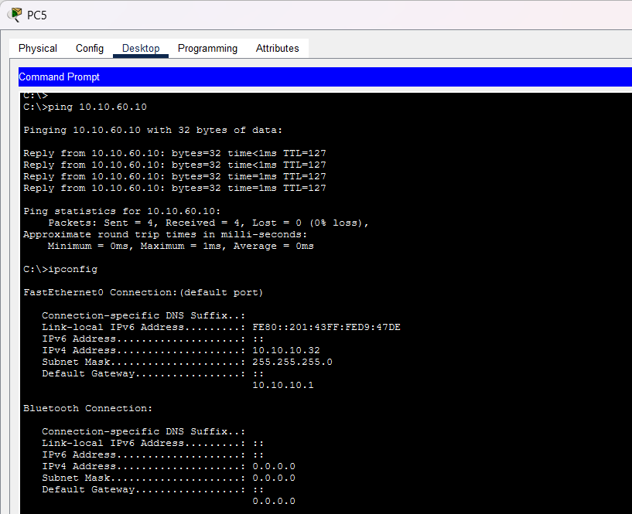The ping test was successful after VLAN, trunk and gateway settings were corrected. This confirmed that routing between the video and server VLANs was operating correctly.

5. MATLAB FFT simulation
Use the following code:
clc;
clear;
close all;

Fs = 8000;
N = 1024;
n = 0:N-1;
t = n/Fs;

x = sin(2*pi*1000*t) + 0.4*sin(2*pi*2500*t);

X = abs(fft(x))/N;
f = (0:N/2)*Fs/N;
singleSpectrum = X(1:N/2+1);

[peakValue, peakIndex] = max(singleSpectrum);
peakFrequency = f(peakIndex);

fprintf('Frequency resolution = %.4f Hz\n', Fs/N);
fprintf('Main peak frequency = %.2f Hz\n', peakFrequency);

figure;
subplot(2,1,1);
plot(t(1:160),x(1:160));
title('Darvycom Test Signal - Time Domain');
xlabel('Time (seconds)');
ylabel('Amplitude');
grid on;

subplot(2,1,2);
plot(f,singleSpectrum);
title('Darvycom Test Signal - Frequency Spectrum');
xlabel('Frequency (Hz)');
ylabel('Magnitude');
grid on;

saveas(gcf,'SIM_02_FFT_Output.png');
Expected command-window output:
Frequency resolution = 7.8125 Hz
Main peak frequency = 1000.00 Hz
Expected graph:
- one strong peak at approximately 1,000 Hz;
- one smaller peak at approximately 2,500 Hz;
- a time-domain plot showing the combined waveform.

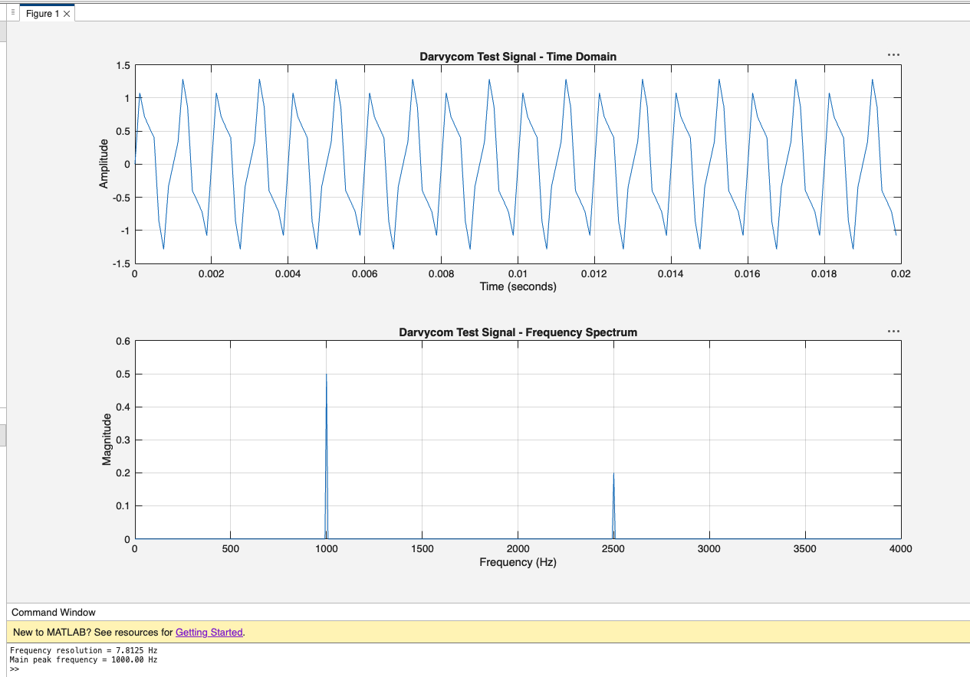6. MATLAB convolution output
Use the following code:
clc;
clear;
close all;

x = [1 2 1];
h = [1 0.5];

y = conv(x,h);

disp('Input sequence:');
disp(x);

disp('Impulse response:');
disp(h);

disp('Convolution result:');
disp(y);

figure;
subplot(3,1,1);
stem(x,'filled');
title('Input Sequence');
xlabel('n');
ylabel('Amplitude');
grid on;

subplot(3,1,2);
stem(h,'filled');
title('Impulse Response');
xlabel('n');
ylabel('Amplitude');
grid on;

subplot(3,1,3);
stem(y,'filled');
title('Linear Convolution Output');
xlabel('n');
ylabel('Amplitude');
grid on;

saveas(gcf,'SIM_03_Convolution_Output.png');
Expected output:
Input sequence:
1 2 1

Impulse response:
1.0000 0.5000

Convolution result:
1.0000 2.5000 2.0000 0.5000

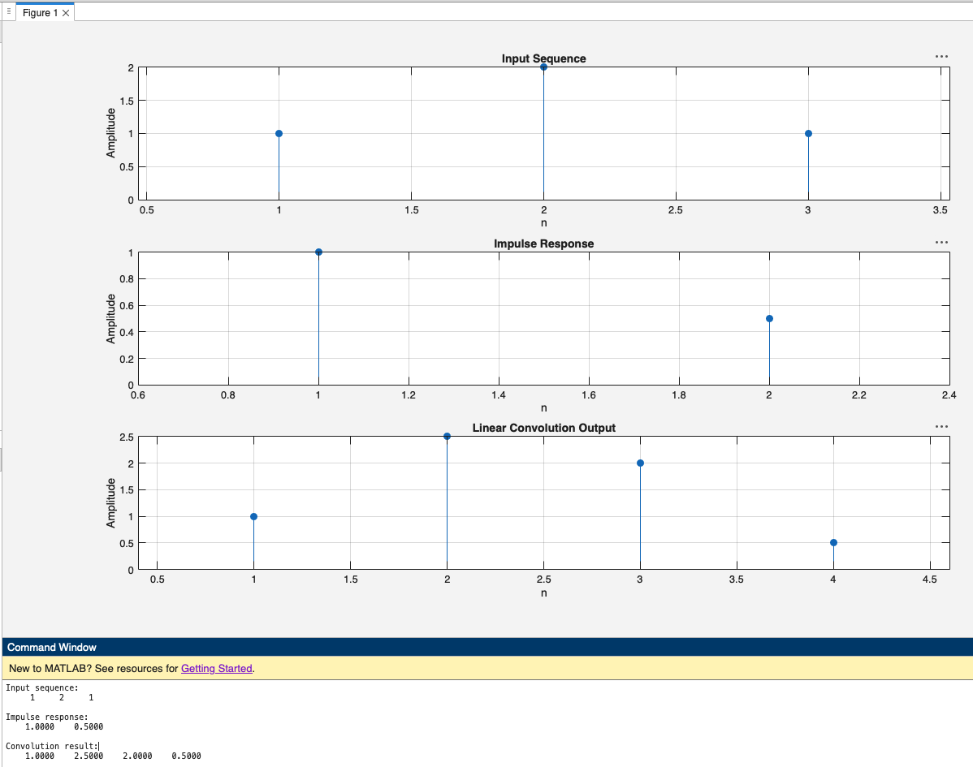7. MATLAB analytical queue output
Use the following code:
clc;
clear;

C = 100e6;
packetSize = 1500;
mu = C/(packetSize*8);

lambda = [5000 7500 9000 4000];
scenario = ["Normal" "Busy" "Overload" "Recovery"];

fprintf('Service rate = %.2f packets/s\n\n',mu);

for i = 1:length(lambda)
rho = lambda(i)/mu;

if rho < 1
W = 1/(mu-lambda(i));
Wq = lambda(i)/(mu*(mu-lambda(i)));

fprintf('%s: lambda = %.0f, rho = %.2f, W = %.3f ms, Wq = %.3f ms\n',...
scenario(i),lambda(i),rho,W*1000,Wq*1000);
else
fprintf('%s: lambda = %.0f, rho = %.2f, queue is unstable\n',...
scenario(i),lambda(i),rho);
end
end
Expected output:
Service rate = 8333.33 packets/s

Normal: lambda = 5000, rho = 0.60, W = 0.300 ms, Wq = 0.180 ms
Busy: lambda = 7500, rho = 0.90, W = 1.200 ms, Wq = 1.080 ms
Overload: lambda = 9000, rho = 1.08, queue is unstable
Recovery: lambda = 4000, rho = 0.48, W = 0.231 ms, Wq = 0.111 ms
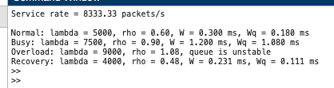

8. Queue control simulation
Use the following code to show queue growth, overload and recovery:
clc;
clear;
close all;

C = 100e6;
packetSize = 1500;
mu = C/(packetSize*8);

dt = 0.01;
t = 0:dt:40;
capacity = 1000;

lambda = zeros(size(t));
lambda(t < 10) = 5000;
lambda(t >= 10 & t < 20) = 7500;
lambda(t >= 20 & t < 30) = 9000;
lambda(t >= 30) = 4000;

q = zeros(size(t));
drops = zeros(size(t));
state = zeros(size(t));

for k = 1:length(t)-1
proposedQueue = q(k) + (lambda(k)-mu)*dt;

if proposedQueue < 0
proposedQueue = 0;
end

if proposedQueue > capacity
drops(k+1) = drops(k) + proposedQueue-capacity;
q(k+1) = capacity;
else
drops(k+1) = drops(k);
q(k+1) = proposedQueue;
end

occupancy = q(k+1)/capacity;

if occupancy < 0.50
state(k+1) = 1; % GREEN
elseif occupancy < 0.75
state(k+1) = 2; % AMBER
else
state(k+1) = 3; % RED
end
end

figure;
subplot(3,1,1);
plot(t,q,'LineWidth',1.5);
yline(500,'--','AMBER threshold');
yline(750,'--','RED threshold');
title('Queue Occupancy');
xlabel('Time (seconds)');
ylabel('Packets');
grid on;

subplot(3,1,2);
plot(t,lambda,'LineWidth',1.5);
yline(mu,'--','Service rate');
title('Arrival and Service Rates');
xlabel('Time (seconds)');
ylabel('Packets/second');
grid on;

subplot(3,1,3);
plot(t,drops,'LineWidth',1.5);
title('Cumulative Packet Drops');
xlabel('Time (seconds)');
ylabel('Packets');
grid on;

saveas(gcf,'SIM_06_Queue_Control_Output.png');

fprintf('Maximum queue = %.0f packets\n',max(q));
fprintf('Total calculated drops = %.0f packets\n',drops(end));
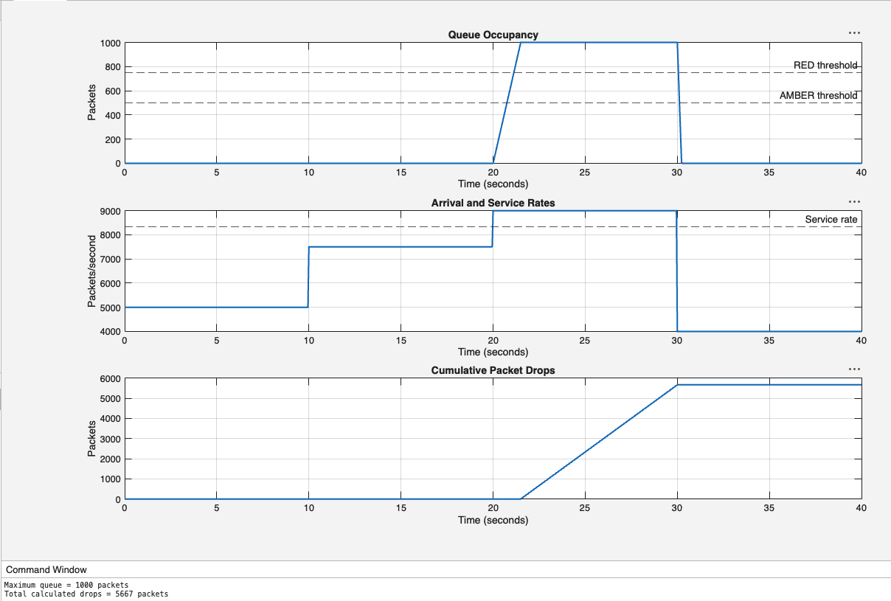

9. First-order controller simulation
clc;
clear;
close all;

tau = 2;
t = 0:0.01:10;
y = 1-exp(-t/tau);

figure;
plot(t,y,'LineWidth',1.5);
yline(0.632,'--','63.2%');
yline(0.950,'--','95%');
xline(2,'--','One time constant');
xline(6,'--','Three time constants');

title('Recovery Controller Step Response');
xlabel('Time (seconds)');
ylabel('Restored Data Allocation');
grid on;

saveas(gcf,'SIM_07_Controller_Response.png');
Expected result:
- approximately 63.2% restoration after two seconds;
- approximately 95% restoration after six seconds;
- smooth recovery without an immediate full-bandwidth change.
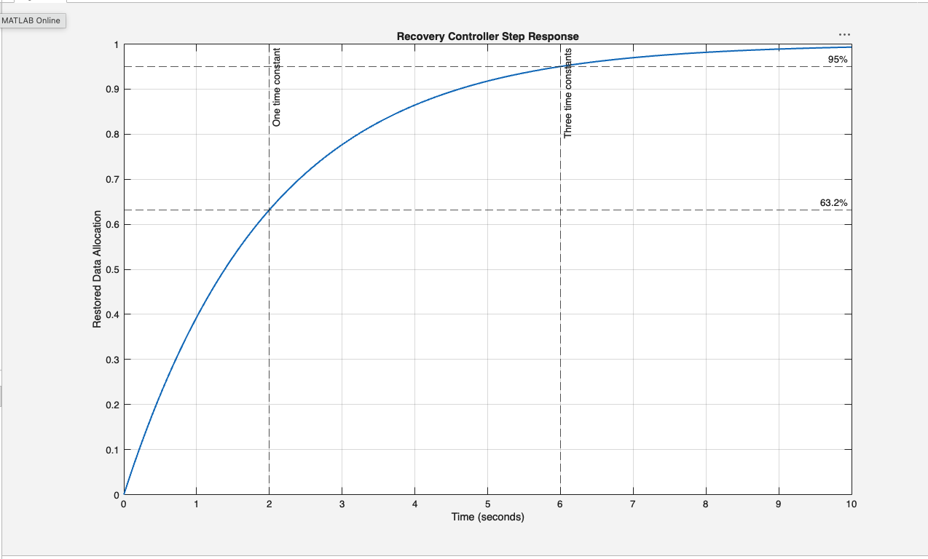

10. PRTG monitoring output
PRTG can be used at home to produce representative evidence of monitoring functions.
Suitable evidence includes:
- Ping Sensor output;
- Windows Network Card or Wi-Fi traffic sensor;
- bandwidth graph;
- latency and packet-loss values;
- sensor status and alarm thresholds.
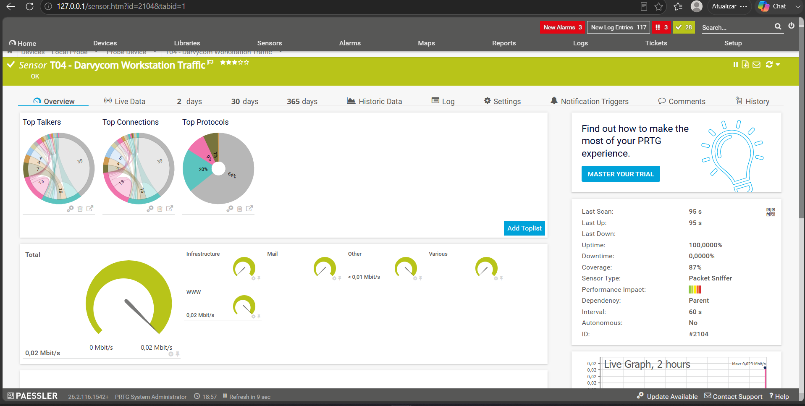 “Representative home-lab monitoring evidence used to demonstrate the monitoring method..”
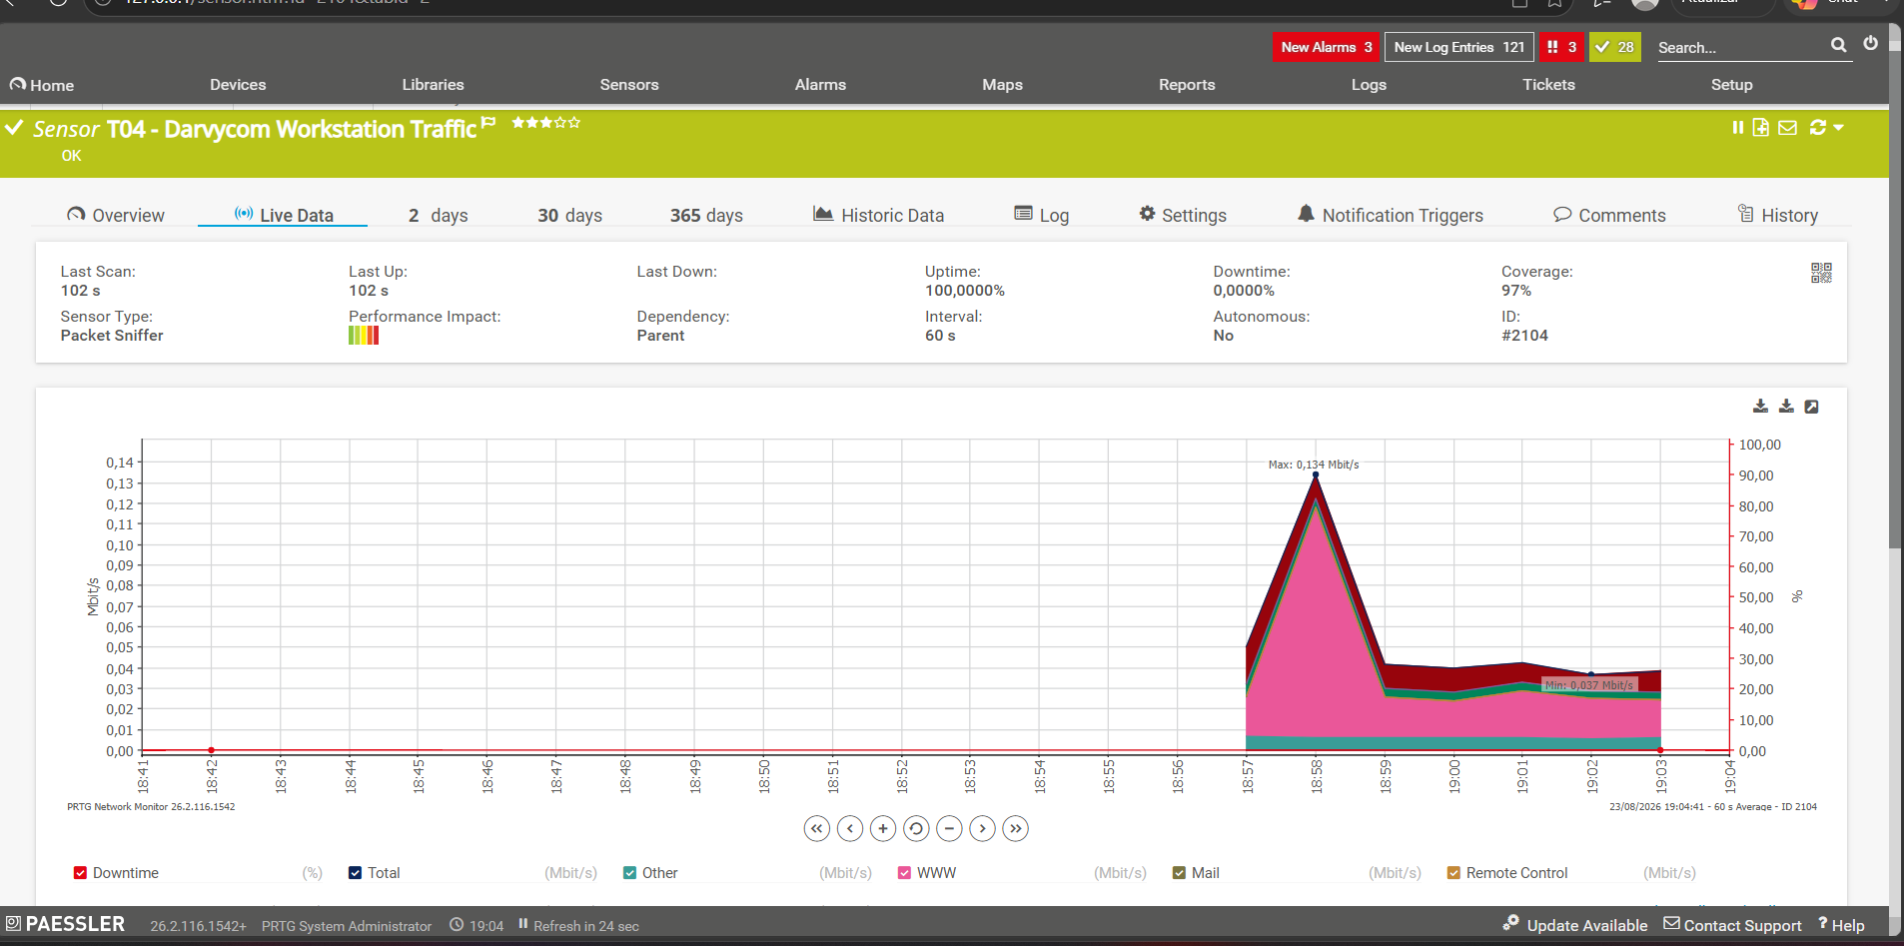PRTG Wi-Fi traffic graph

11. Conclusion
The software simulations support the Darvycom Network 3 design. Packet Tracer verified network connectivity, MATLAB supports the mathematical and DSP results, and PRTG demonstrates how operational monitoring can be performed. The overload simulation also confirms that QoS, threshold alarms and data rate control are required when traffic exceeds the output-link service rate.

